**Project:**

Power Company Billing System

**Description:**

This project is intended to demonstrate how a power utility company would determine monthly charges for the customers given their units of consumption and location of the premise where power is consumed.

The project is done using Python as the programming language, Text file and MySQL server.

**Installation:**

In case you need to have a full end-to-end experience with the system, you will require to install MySQL in your computer environment.

Otherwise if you don’t want to use MySQL then you will have to connect every section of the code that references MySQL.

For the text file, please change the location of the file to point to your own computer environment.

**How to Use This Project:**

Once you have the environment set, you just run the program. It will display the menus on the screen.

To add a New Customer press 1. On the New Customer screen, you will be prompted for customer number, which must be non-floating number, and then you add other details including names, contact and zone of the premise using the power. Save. The details will be saved in both text file and MySQL.

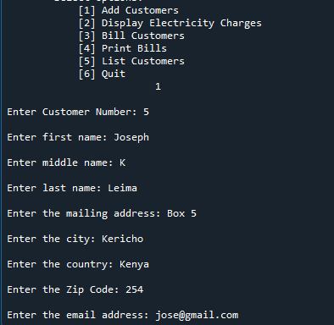

In order to know the current recommended electricity tariff, you will press 2 on the menu.

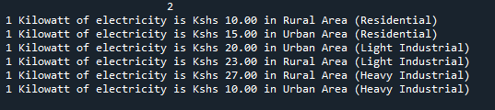

To bill a customer, you will press 3. This will prompt for an existing customer ID. If the customer ID if found in the system, the system will prompt for the month and year for billing which are entered as numerics only. You will finally be prompted for the units consumed in the month and the system will do calculation for the cost to be charged. The system uses prorated discount rates and charges also depend on the location of premise. Finally, there are various taxes loaded onto the customer bill. A bill is automatically generated on finishing calculations.

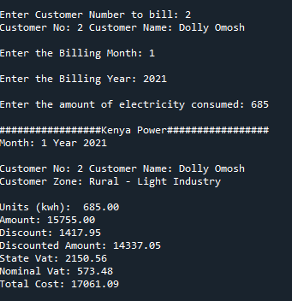

The system stores the bills in the database. To obtain a previous bill, you will require to press 4 on the menu menu.

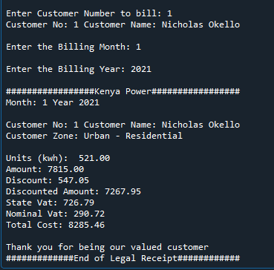

Finally the system is able to show the details of the customers so that in case there is non payment of bill or customer reports a problem with power at his site then he can be easily traced to his place.

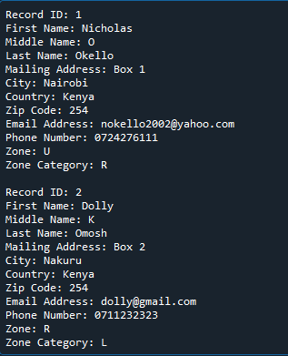

**Author:**

Nicholas Okello